
ОБЩЕСТВО С ОГРАНИЧЕННОЙ ОТВЕТСТВЕННОСТЬЮ
«ЛАЗЕРТАГ»

ПАСПОРТ

Смоленск
LIMITED LIABILITY COMPANY
LASERWAR

SPECIFICATION

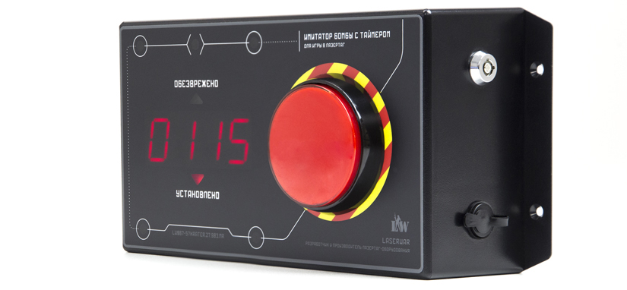

Laser tag device
CRATER BOMB

7. Contact information
Official site:
www.laserwar.com

Email:
info@laserwar.com
help@laserwar.com

Skype:
info@laserwar.com
help@laserwar.com

_____________________
signature

Dear Customer!
LASERTAG LLC welcomes you and thanks you for choosing our products, and also expresses confidence that the product you purchased will bring you pleasure and will last a long time. This coupon establishes a warranty liability for the product in the amount provided by the Law of the Russian Federation "On Protection of Consumer Rights".
This warranty card is valid for 12 months from the date of purchase of the product subject to the terms of the guarantee.

2
11

Date of purchase:_______________

1. Purpose
CRATER laser tag bomb - an additional device designed to play in laser tag.

2. Technical specifications
Weight | 0.5 kg
Dimensions | 22.5 x 10.5 x 6 centimeters
Number of IR emitters | 4
Battery type | Li;
Charger type | 7.5 V, 2200 mAh
Battery life | Li +

- Package Contents
№  п/п | Name | unit of measurement | amount
1. | Bomb | PC. | 1
2. | Passport products | PC. | 1

Information about the repairs carried out during the period of guaranteed service (to be filled in by the service center performing the warranty repair)

Date:__________________Completed work:  _____________________________________________________________________  Printing Service Center | Date:__________________  Completed work:  _____________________________________________________________________  Printing Service Center
Date:__________________Completed work:  _____________________________________________________________________  Printing Service Center | Date:__________________Completed work:  _____________________________________________________________________  Printing Service Center
Date:__________________Completed work:  _____________________________________________________________________  Printing Service Center | Date:__________________Completed work:  _____________________________________________________________________  Printing Service Center

3
10
4. Description and work
4.1. Device
CRATER laser tag bomb is made in a plastic case in black. The main body is a structure in which an acoustic annunciator, a battery element, control units, and module fastening elements are installed. On the body there is a power-on lock, an activation button, a battery charging socket.
Laser-bomb "Crater" is an additional device, imitating a bomb. Players who are in the radius of its action when triggered, immediately lose all the health points.

Terms of guarantee:
1. The guarantee becomes effective upon presenting the present coupon, which indicates the date of purchase of the equipment, confirmed by the service center.
2. These warranty obligations apply to products purchased only from an official representative of LLC LASERTAG, or its Official Dealer.
3. This warranty is void if defects in the product have occurred in the event of:
- non-observance of Instructions for use;
- mechanical damage;
- ingress of foreign objects, liquids, etc .;
- animal activities;
- unauthorized access to sites and details of persons who are not authorized to carry out specified actions;
- use of the product for purposes for which it is not provided;
- acts of force majeure (natural catastrophe, fire, accident, etc.);
- failure of the product due to improper connection, a faulty electrical outlet and / or poor maintenance of the product.
4. If the warranty card is lost, the duplicate does not issue.

4
9
4.2. Changing the TTX of the game set
To change the settings of CRATER laser tag bomb it is necessary to turn it on with a clamped red button. The timing settings for the installation of a bomb, its demining and confirmation by a shot are changed with the help of the laser tag configurator.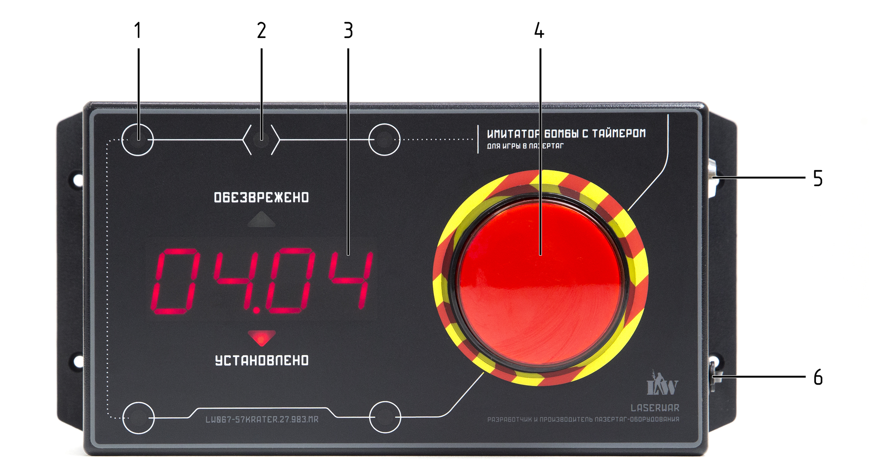
1. IR emitter
2. IR Receiver
3. Seven-segment display
4. Set / deactivate button
5. Power switch
6. Power socket

6. Warranty
The manufacturer guarantees the reliability of the individual set of LASERWAR when the user observes the operating conditions consumer complies with the rules of transportation, storage, operation and payment for the delivery of faulty equipment. The manufacturer undertakes to replace or repair the individual set of equipment free of charge, provided that the to the city of Smolensk.
On the batteries, speakers, IR-modules warranty is 14 DAYS.
ATTENTION! In the event of improper use of batteries (charging by an inappropriate type of charger), the battery warranty does not apply!

With full technical guidance on the operation of LASERWAR laser tag equipment, you can visit our website at www.laserwar.com

5
8
6
7
4.3. Preparation for work
Laser-bomb "Crater" is turned on by turning the key. Installation / deactivation of the bomb is done by pressing the red button. After the end of the round, you can start the game either with the help of any LASEWRAR remote control, or by repeatedly turning off and on the game set.

5. Rules of operation
1. Weather conditions. We strongly advise against using the equipment in rain and at temperatures as low as -20 ° C.
Avoid getting moisture inside the layout. If this happens, stop the operation, dry the equipment at room temperature for at least 2 hours.
In no case can not immediately put on a charge equipment, used at low temperatures. It is necessary to allow the electronics to warm up, to dry the condensate, which occurs when the weather conditions change sharply.
2. Accumulators. As a power source in the laser-tag-bomb "Crater" lithium batteries are used. To recharge them, you need only use Li + chargers.
First of all, you need to connect the charger to the device, and then - to the network.
The recharging process can be controlled with a special indicator. If the battery is low, the LED lights red; At the end of the charging process, the color of the glow changes to green.
Attention! Recharge the device immediately after use under constant supervision at an ambient temperature of at least 0 ° C for no more than 2 hours.

Store the equipment only in a charged state (ideally - at the rated voltage of the battery).

